Billing Update: New Payment System Launch Moved to May
We are excited to announce an upgrade to our online billing platform with Point & Pay, designed to make managing your account easier, faster, and more convenient. The transition has been rescheduled to Monday, May 4th, and customers can expect to receive setup emails in early May.
Please note these important updates:
- New Launch Date: The transition will take place on Monday, May 4th.
- Watch Your Email: Customers with an email on file will receive setup instructions in early May. Be sure to check your inbox, junk, and promotions folders so you don’t miss it.
  - Emails will be sent from “noreply+Wasatch-fwr-district@paydici.com”
- AutoPay Users - Action Required: If you are currently enrolled in AutoPay, you must re-register and enter your payment information.
  - Because this is a new vendor, existing payment details cannot be transferred.
- Until you receive your setup email, please continue using the current payment system.

The new platform offers several benefits for residents, including:
- Faster, more user-friendly online payment experience
- Continued secure and reliable transaction processing
- Flexible and expanded payment options, including AutoPay, scheduled, and one-time payments, now including American Express, Google Pay, and Apple Pay
- Paperless billing for easier account management
- Text and email reminders so you never miss a payment
- Multiple language options for added accessibility
We encourage you to act promptly once your setup email arrives to ensure a smooth transition and convenient billing experience for everyone.

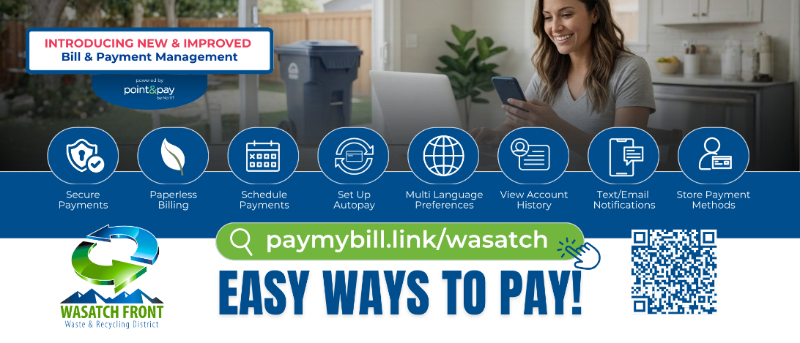
Incoming: New Residential Specialty Curbside Collection Services
Effective May 1, 2026, WFWRD will introduce new residential specialty curbside collection services for bulky waste items that present unique operational, environmental, and regulatory challenges. Offered year-round, this program is designed to complement WFWRD’s Seasonal Container Reservation Program (SCRP) by providing convenient and cost-effective collection options for the following materials:
- Tires* (up to 12 per household, per pickup)
- Mattresses and Box Springs
- Freon-containing Appliances (refrigerators, air conditioners)
- Non-Freon-containing Appliances (ovens, ranges, hot water heaters, etc.)
* Automotive-sized tires and smaller. Large equipment tires are not eligible for pickup.

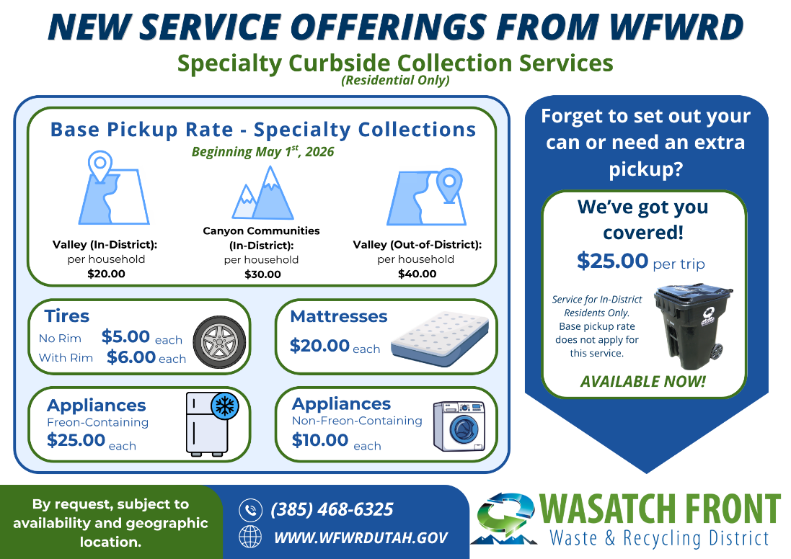

Visit our website (www.WFWRDUtah.gov) to request your curbside pickup. Due to liability reasons, WFWRD staff are unable to enter homes, fenced areas, or garages. Items must be placed at the curb on your scheduled pickup day, which will be communicated in advance.

Additional items eligible for pickup (e.g., couches, large-screen TVs) may be added over time as we learn more about our community’s needs.

The overwhelming majority of these items will be recycled, helping to reduce our environmental footprint and preserve valuable landfill space. Tires will be hauled to a waste tire recycling facility, mattresses and box springs to a disassembly and recovery facility, and certified specialists will safely recover freon from appliances before they are sent to a scrap metal recycling facility. It’s a win-win for everyone!

