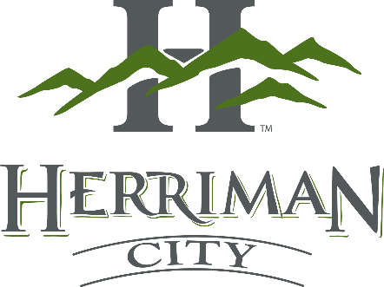

PUBLIC NOTICE

The Herriman City Council hereby gives notice of the adoption of an Ordinance at the meeting held on May 14, 2026, at 7:00 p.m. in the City Hall Council Chambers, 5355 West Herriman Main Street, Herriman, Utah, as follows: Ordinance No. 2026-10 approving a Development Agreement to permit Awaken City Church in an M-1 Manufacturing Zone at 15856 S Rockwell Park Cove. A copy is available to interested persons by contacting the City Recorder’s Office during regular business hours. /s/ Jackie Nostrom, City Recorder

Published: 5/14/2026:
Utah Public Notice Website
Herriman City Website
Notice Board at the Herriman City Hall

