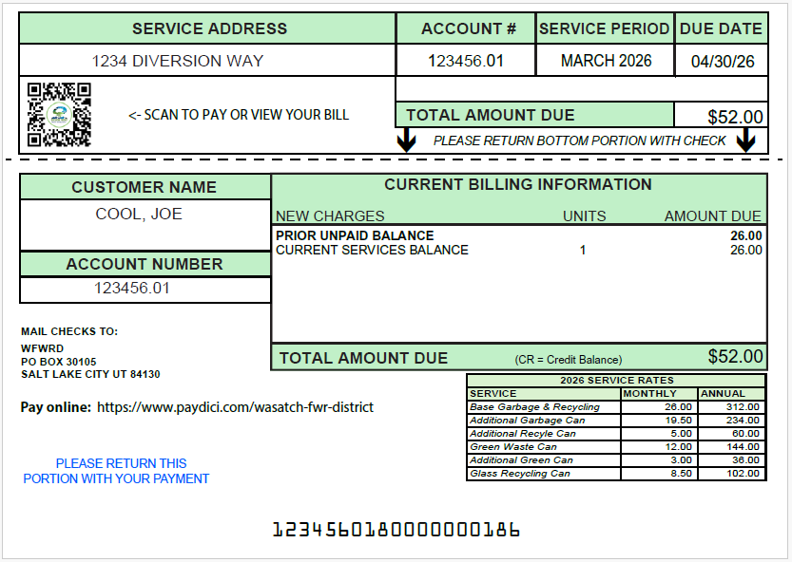
Postcard Billing

In a continued effort to keep costs down and retain reasonable service pricing, WFWRD has identified a cost savings measure that will save $190,000 per year on printing and postage costs. Your next WFWRD billing statement will be in the form of a 6” x 4.25” postcard as opposed to a full-size page as we have done in the past.

This simple change will also reduce the amount of paper and resources necessary for our customers that want to continue to receive paper bills.

Our new payment processing vendor, Point & Pay, went live during the month of May. Please consider signing up for electronic, paperless billing at paymybill.link/wasatch. You can also sign up for convenient automatic payments!

WFWRD Celebrates Waste and Recycling Workers Week

On June 18th, Wasatch Front Waste & Recycling District proudly celebrates our own Waste & Recycling Worker Appreciation Day for our hardworking employees who help keep our communities clean, safe, and running smoothly every day.

From early morning routes to all kinds of weather conditions, garbage and recycling collection teams provide an essential public service that is oftentimes taken for granted. Waste and Recycling Workers Week is an opportunity to show appreciation for their dedication, professionalism, and commitment to protecting public health and the environment.

Residents can celebrate by offering a friendly wave, a thank you, or simply making sure carts are placed out correctly and safely on collection day. Small gestures of appreciation go a long way in recognizing these dedicated workers who help keep our neighborhoods beautiful year-round.

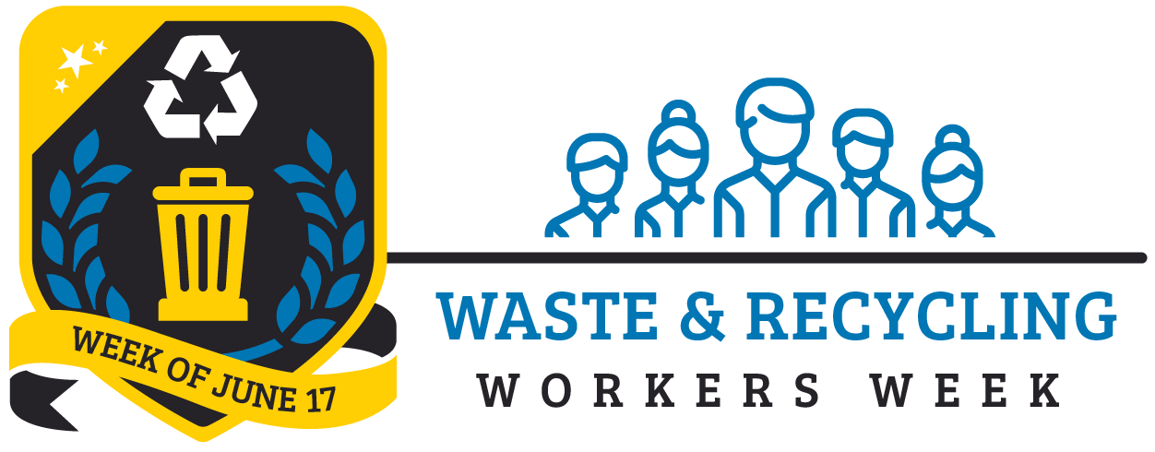
House Bill 107 – Recycling Facility Transparency Amendments


In response to HB107 requiring political subdivisions to publish information about the collection of recyclable materials twice per year, the chart below includes recycling tonnages collected throughout the District’s service areas from November 2025 through April 2026 totaling over 9,000 tons!

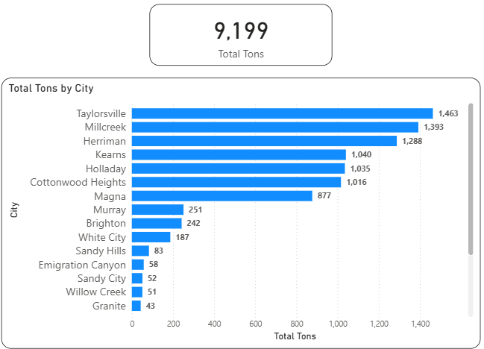

Find year-to-date tonnage and diversion information on our website under the “About” tab “District Statistics”: https://wfwrdutah.gov/about/district-statistics.

