Firework Safety & Disposal Tips

As we gear up for a fun-filled July full of fireworks* and celebrations, please keep in mind a few important safety and disposal guidelines:

*Check with your local municipality or fire department as firework restrictions may be in place

- Cool before you toss: After use, place spent fireworks in a fire-safe container and allow them to cool completely. If possible, soak them in a small bucket of water to prevent accidental flare-ups.
- Do not recycle: Firework casings—even cardboard ones—cannot be recycled. They contain chemical residues and are often made from multiple materials. Once cooled, place them in your black garbage can.
- Save or repurpose: If you have leftover, unused fireworks, consider saving them for Pioneer Day or repurposing them responsibly.
- Think green: Explore environmentally friendly alternatives to fireworks, like laser light shows or LED displays.



Grilling, Camping, & Propane Tanks

Summer means more time spent grilling and camping.
- Allow coals and ash to cool completely for at least 48 hours before attempting to discard them.
- Never throw hot ash directly into household trash or onto the grass.
- Transfer completely cooled ash into a non-combustible, heavy-duty metal container.

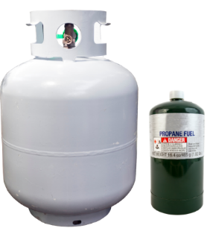
What should you do with empty propane tanks?

All propane tanks—whether large grill tanks or small 1-gallon green camping canisters—are considered Household Hazardous Waste (HHW) and should never be placed in your garbage or recycling can. These tanks pose serious safety risks during collection and processing due to the potential for explosion.

Instead, drop them off at your nearest HHW facility for proper recycling and safe disposal. These sites are free to use and ensure that hazardous materials are handled correctly.

Need help finding a location? Visit the “How to Recycle” page on our website and scroll down to “Household Hazardous Waste Disposal” for a list of nearby drop-off sites.

https://wfwrdutah.gov/how-recycle/hazardous-waste

Download our Mobile App for Service Reminders and More!

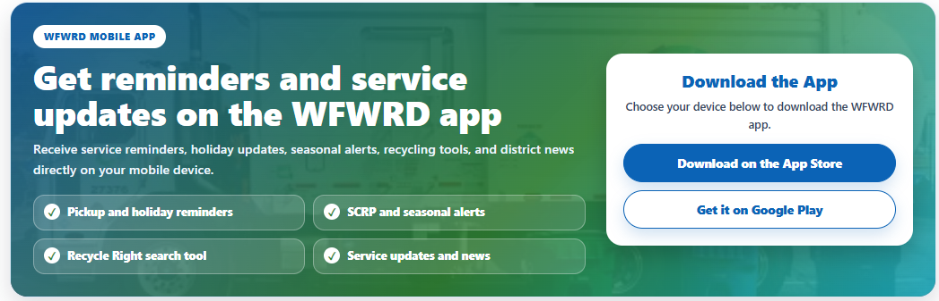
https://apps.apple.com/us/app/wasatch-front-waste/id1507832124 https://play.google.com/store/apps/details?id=org.wasatchfrontwaste.recollect.waste&hl=en_US

