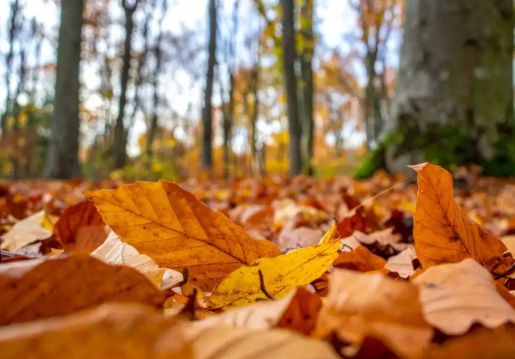
Leaf Bag Drop-off Program

Fall is approaching and leaves will begin changing colors and falling in no time! But don’t worry about them piling up — your team at Wasatch Front Waste & Recycling District is ready to help with the cleanup.

Every autumn, we set up convenient leaf bag drop-off locations so you can clear your leaves without overloading your curbside waste containers. When your bags are full, bring them to one of our leaf bag drop-off sites.

We’ll have these sites available for leaf bag drop-off from October 15 through November 30. Check our website for more information and a list of drop off locations.

https://wfwrdutah.gov/basic-services/seasonal-services/leaf-program

- It is okay to set the bags on the ground near the WFWRD containers when full.
- Please do not dump garbage, yard waste, or other items at the leaf bag collection sites.
- Reminder: Leaves are not accepted in blue recycling cans.
- This program is funded through residential user fees and is intended for District residential customers only!
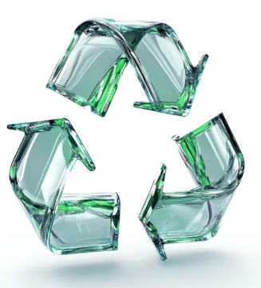
Glass Recycling 101

Did you know that glass is one of the few materials that can be recycled again and again without losing its quality? By recycling glass, you can help conserve natural resources and reduce the energy needed to produce new glass.

Wasatch Front Waste and Recycling District, in cooperation with Momentum Recycling, makes recycling glass easy. We provide free public glass recycling drop-off bins at several locations throughout the District. Visit Glass Recycling | Wasatch Front Waste & Recycling District to find a location near you.

Note: Drop-off locations are for residential glass recycling only. Glass must be placed directly inside the designated bins. Please do not leave bags, boxes, or other materials on the ground.

Diversion Rate

With your help, we are holding strong with our District-wide 2026 Diversion Rate Goal of 18%!

The District's diversion rate is the percentage of residential municipal waste diverted from the landfill through reuse, reduction, recycling, and composting programs. Below are the tonnages for your community from January through July 2026:

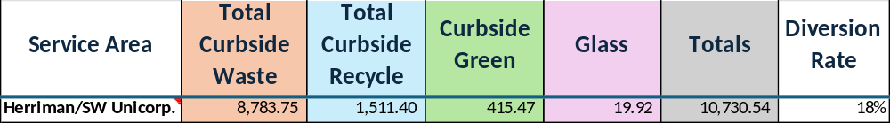
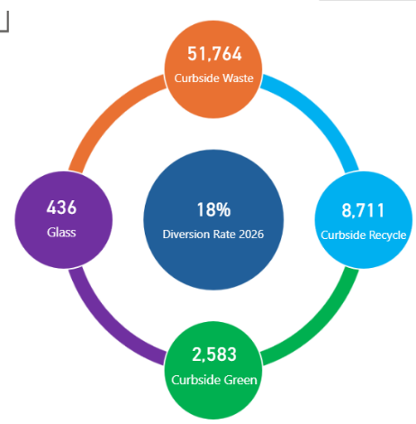
After our landfills meet capacity, trash will need to be transported out of the valley, increasing vehicles on the road, emissions, and transportation costs. Diverting from the landfill supports the longevity of the landfills and reduces adverse impacts to the environment. WFWRD offers multiple diversion opportunities including recycling, glass recycling, and subscription weekly curbside green waste collection.

Check our website and follow us on social media to find out how you can help to divert more waste from the landfill: www.wfwrdutah.gov.

